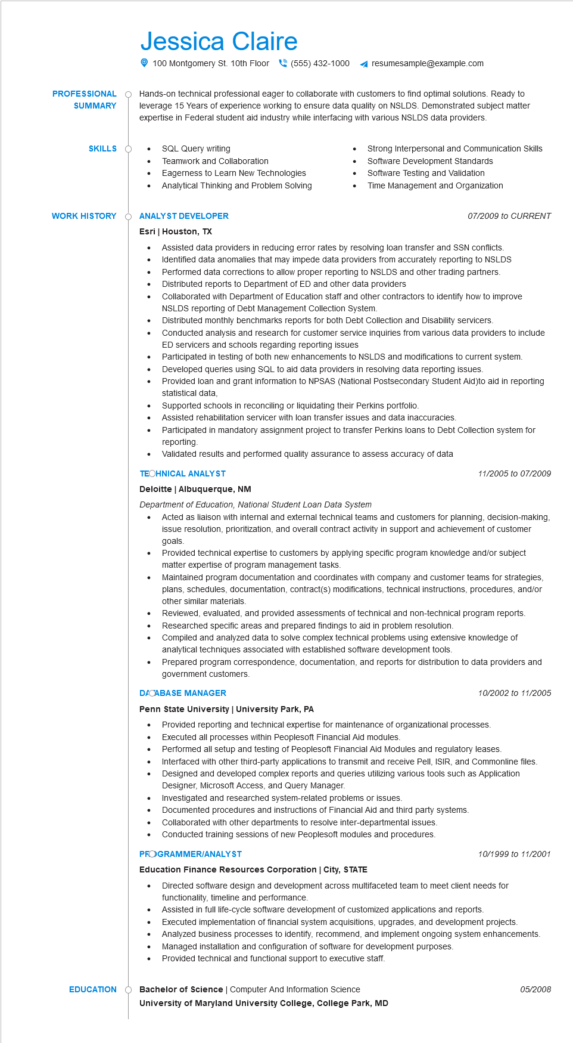
PROFESSIONAL
SUMMARY
SKILLS
WORK HISTORY
Jessica Claire
100 Montgomery St. 10th Floor(555) 432-1000 4 resumesample@example.com
Hands-on technical professional eager to collaborate with customers to find optimal solutions. Ready to leverage 15 Years of experience working to ensure data quality on NSLDS. Demonstrated subject matter expertise in Federal student aid industry while interfacing with various NSLDS data providers.
• SQL Query writing
Teamwork and Collaboration
•
Eagerness to Learn New Technologies Analytical Thinking and Problem Solving
O ANALYST DEVELOPER
Esri | Houston, TX
•
•
•
Strong Interpersonal and Communication Skills
Software Development Standards
Software Testing and Validation
Time Management and Organization
07/2009 to CURRENT
Assisted data providers in reducing error rates by resolving loan transfer and SSN conflicts. Identified data anomalies that may impede data providers from accurately reporting to NSLDS
•
Performed data corrections to allow proper reporting to NSLDS and other trading partners. Distributed reports to Department of ED and other data providers
•
•
•
Collaborated with Department of Education staff and other contractors to identify how to improve NSLDS reporting of Debt Management Collection System.
Distributed monthly benchmarks reports for both Debt Collection and Disability servicers.
Conducted analysis and research for customer service inquiries from various data providers to include ED servicers and schools regarding reporting issues
Participated in testing of both new enhancements to NSLDS and modifications to current system.
Developed queries using SQL to aid data providers in resolving data reporting issues.
Provided loan and grant information to NPSAS (National Postsecondary Student Aid)to aid in reporting statistical data,
Supported schools in reconciling or liquidating their Perkins portfolio.
Assisted rehabilitation servicer with loan transfer issues and data inaccuracies.
Participated in mandatory assignment project to transfer Perkins loans to Debt Collection system for reporting.
Validated results and performed quality assurance to assess accuracy of data
TECHNICAL ANALYST
Deloitte | Albuquerque, NM
Department of Education, National Student Loan Data System
•
11/2005 to 07/2009
Acted as liaison with internal and external technical teams and customers for planning, decision-making, issue resolution, prioritization, and overall contract activity in support and achievement of customer goals.
Provided technical expertise to customers by applying specific program knowledge and/or subject matter expertise of program management tasks.
Maintained program documentation and coordinates with company and customer teams for strategies, plans, schedules, documentation, contract(s) modifications, technical instructions, procedures, and/or other similar materials.
Reviewed, evaluated, and provided assessments of technical and non-technical program reports. Researched specific areas and prepared findings to aid in problem resolution.
• Compiled and analyzed data to solve complex technical problems using extensive knowledge of analytical techniques associated with established software development tools.
• Prepared program correspondence, documentation, and reports for distribution to data providers and government customers.
DACABASE MANAGER
Penn State University | University Park, PA
10/2002 to 11/2005
. Provided reporting and technical expertise for maintenance of organizational processes. Executed all processes within Peoplesoft Financial Aid modules.
•
•
Performed all setup and testing of Peoplesoft Financial Aid Modules and regulatory leases. Interfaced with other third-party applications to transmit and receive Pell, ISIR, and Commonline files. Designed and developed complex reports and queries utilizing various tools such as Application Designer, Microsoft Access, and Query Manager.
•
Investigated and researched system-related problems or issues.
Documented procedures and instructions of Financial Aid and third party systems.
•
Collaborated with other departments to resolve inter-departmental issues.
Conducted training sessions of new Peoplesoft modules and procedures.
PROGRAMMER/ANALYST
Education Finance Resources Corporation | City, STATE
10/1999 to 11/2001
• Directed software design and development across multifaceted team to meet client needs for functionality, timeline and performance.
Assisted in full life-cycle software development of customized applications and reports.
•
•
Executed implementation of financial system acquisitions, upgrades, and development projects. Analyzed business processes to identify, recommend, and implement ongoing system enhancements. Managed installation and configuration of software for development purposes.
Provided technical and functional support to executive staff.
EDUCATION
Bachelor of Science | Computer And Information Science University of Maryland University College, College Park, MD
05/2008

